**PROOF OF TESTING**

**PYTHON Problem 4**

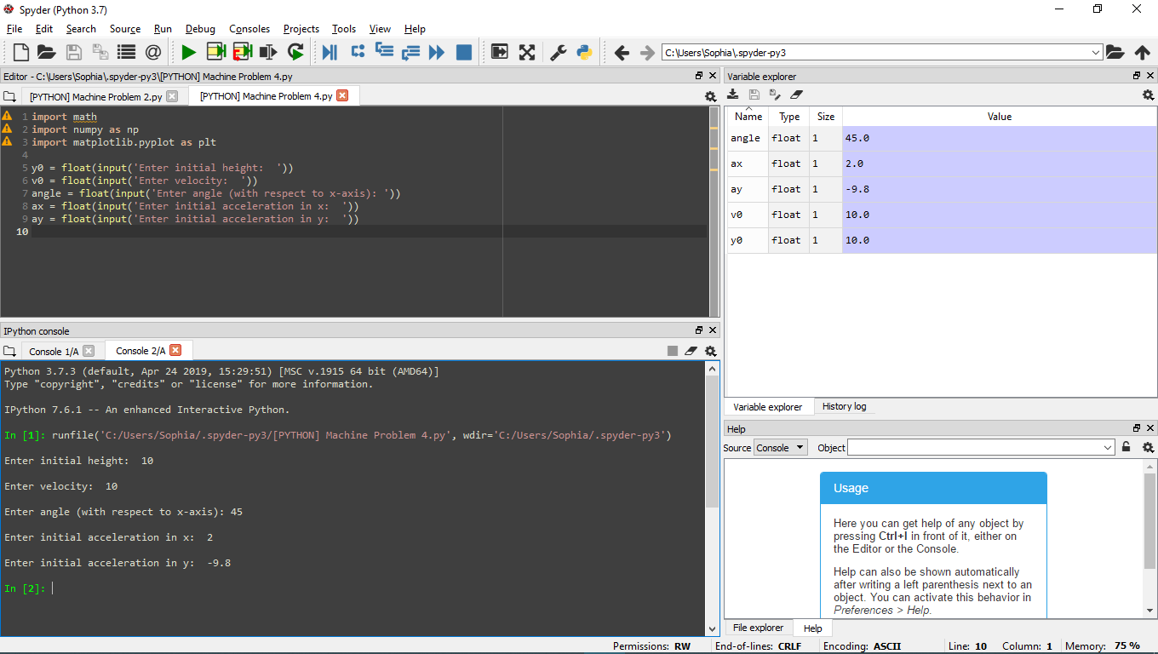**For vertical acceleration not equal to zero:**

**User input for values: initial height, velocity, angle, acceleration for both x and y.**

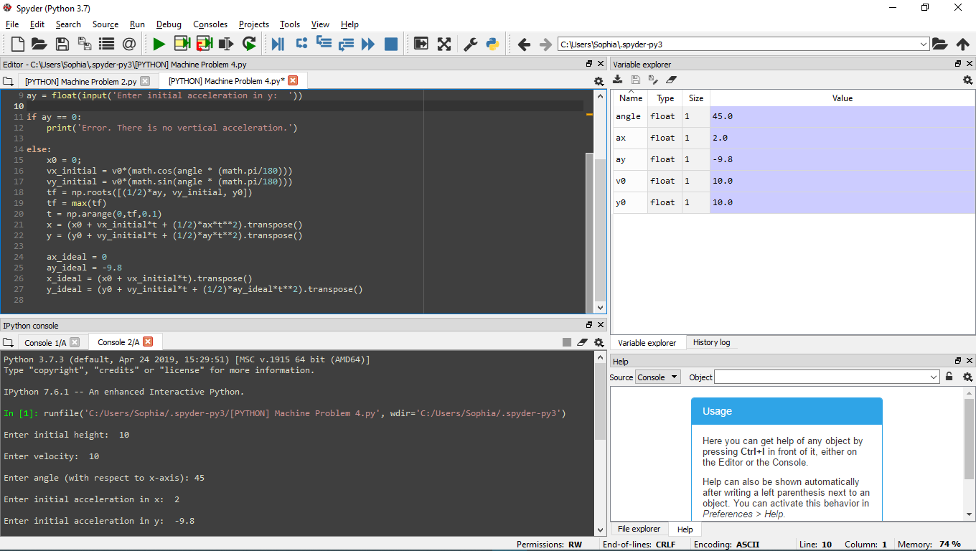

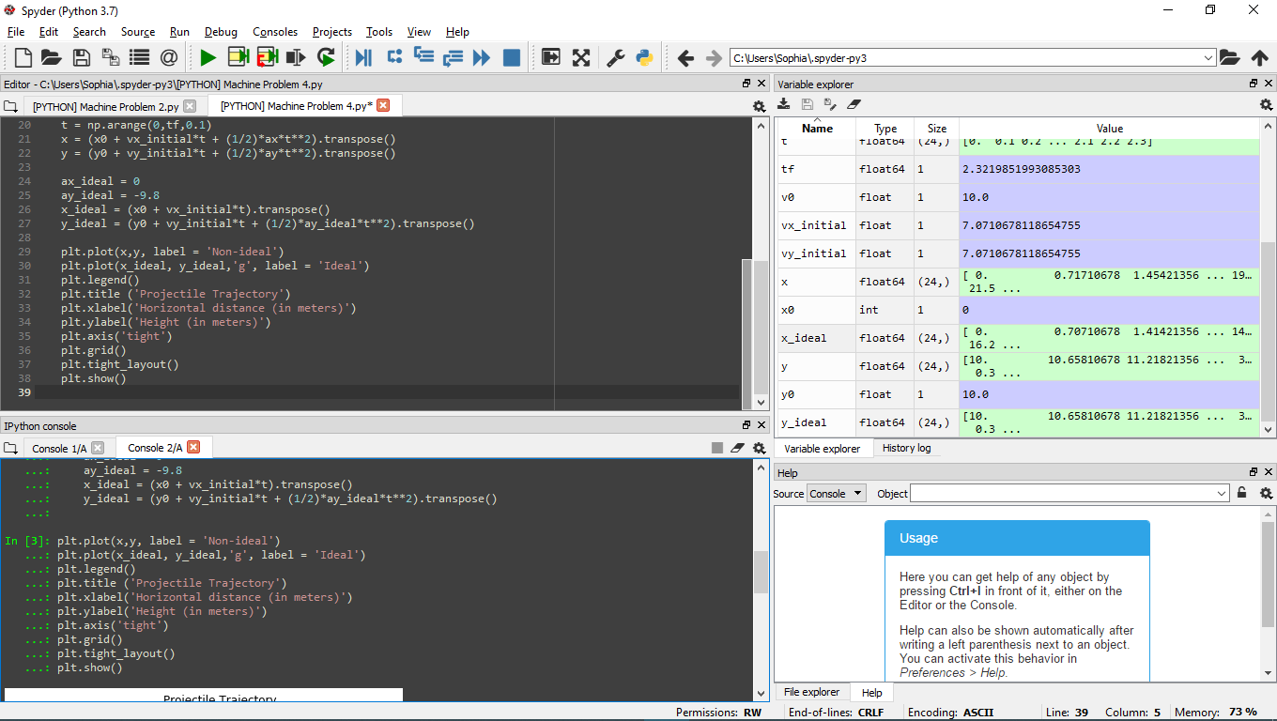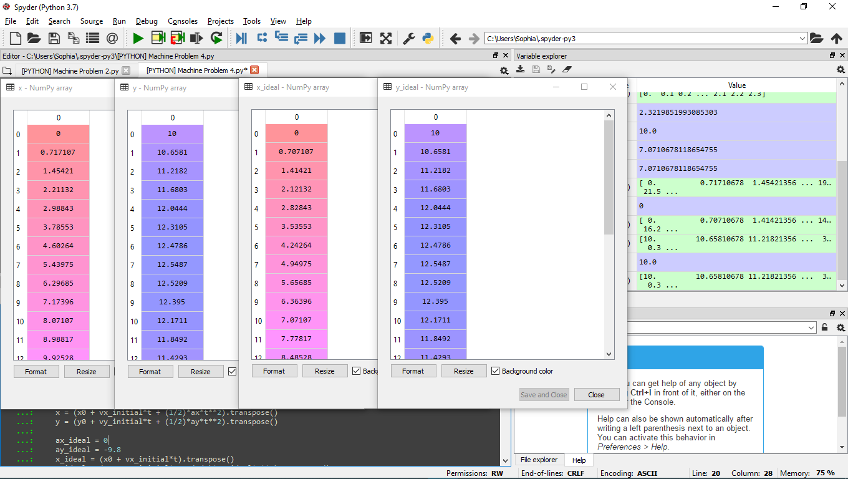

**Values of x,y for both non-ideal & ideal**

**Superimpose plotting for both non-deal and ideal**

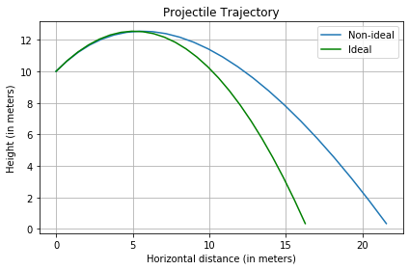

**For vertical acceleration equal to zero.**

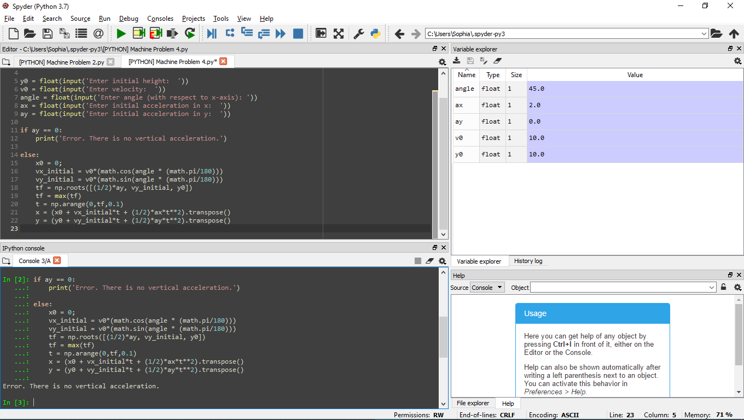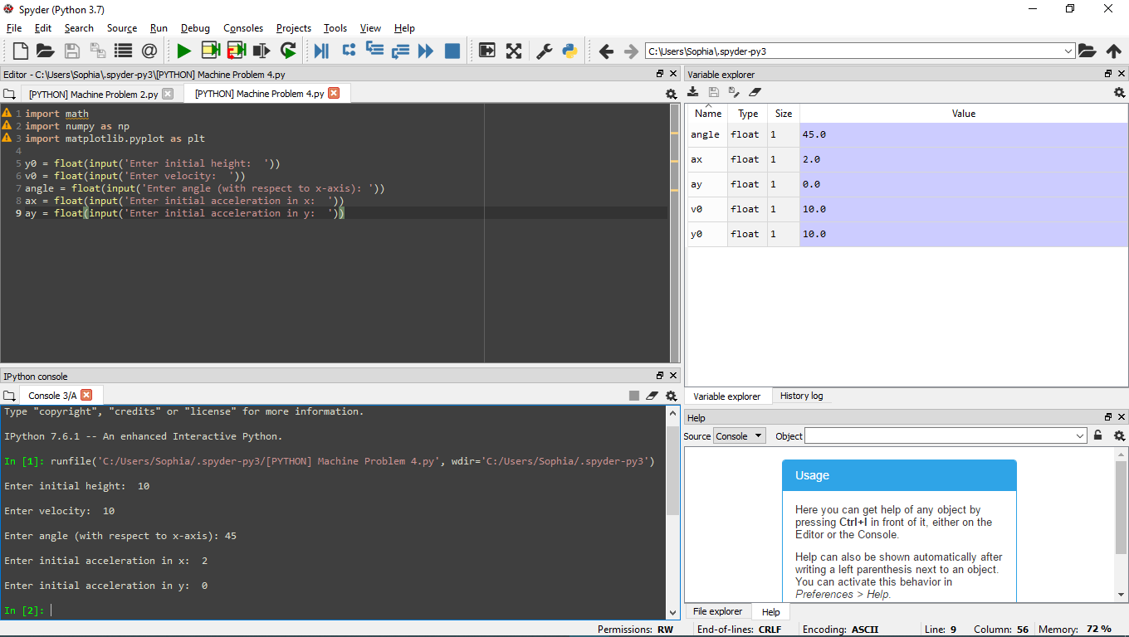

**User input vertical acceleration equal to zero**

**Displays error message.**